**HARMFUL AND BENEFICIAL 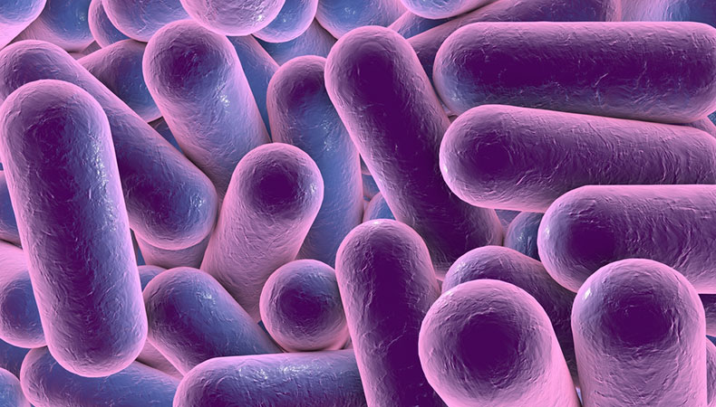MICROORGANISMS**

Group Members –

Harshil Bhandari (16ume016)

Harshit Khandelwal (16ume017)

Himanshu Doble (16ume018)

Kanishak Godara (16ume019)

Karan Singh Chouhan (16ume020)

Kaustubh Nirwan (16ume021)

* Kaustubh Nirwan (16ume021)

**MICROORGANISMS**

A microorganism or microbe is a [microscopic](https://en.wikipedia.org/wiki/Microscopic_scale) [organism](https://en.wikipedia.org/wiki/Organism), which may exist in its [single-celled](https://en.wikipedia.org/wiki/Unicellular_organism) form, or in a [colony of cells](https://en.wikipedia.org/wiki/Colony_(biology)#Microbial_colonies).

The possible existence of unseen microbial life was suspected from ancient times, such as in [Jain scriptures](https://en.wikipedia.org/wiki/Jain_scriptures) from [6th century BC](https://en.wikipedia.org/wiki/6th_century_BC) India, and the [1st century BC](https://en.wikipedia.org/wiki/1st_century_BC), book *On Agriculture* by [Marcus Terentius Varro](https://en.wikipedia.org/wiki/Marcus_Terentius_Varro). [Microbiology](https://en.wikipedia.org/wiki/Microbiology), the scientific study of microorganisms, began with their observation under the [microscope](https://en.wikipedia.org/wiki/Microscope) in the 1670s by [Antonie van Leeuwenhoek](https://en.wikipedia.org/wiki/Antonie_van_Leeuwenhoek). In the 1850s, [Louis Pasteur](https://en.wikipedia.org/wiki/Louis_Pasteur) found that microorganisms cause [food spoilage](https://en.wikipedia.org/wiki/Food_spoilage), debunking the theory of [spontaneous generation](https://en.wikipedia.org/wiki/Spontaneous_generation). In the 1880s [Robert Koch](https://en.wikipedia.org/wiki/Robert_Koch) discovered that microorganisms caused the diseases [tuberculosis](https://en.wikipedia.org/wiki/Tuberculosis), [cholera](https://en.wikipedia.org/wiki/Cholera), and [anthrax](https://en.wikipedia.org/wiki/Anthrax).

Microorganisms include all [unicellular organisms](https://en.wikipedia.org/wiki/Unicellular_organism), and so are extremely diverse. Of the [three domains of life](https://en.wikipedia.org/wiki/Three-domain_system) identified by [Carl Woese](https://en.wikipedia.org/wiki/Carl_Woese), all of the [Archaea](https://en.wikipedia.org/wiki/Archaea), and [Bacteria](https://en.wikipedia.org/wiki/Bacteria) are microorganisms. These were previously grouped together in the [two domain system](https://en.wikipedia.org/wiki/Two-empire_system) as [Prokaryotes](https://en.wikipedia.org/wiki/Prokaryotes), the other being the eukaryotes. The third domain [Eukarya](https://en.wikipedia.org/wiki/Eukaryota) includes all [multicellular organisms](https://en.wikipedia.org/wiki/Multicellular_organism), and many unicellular [protists](https://en.wikipedia.org/wiki/Protist) and [protozoans](https://en.wikipedia.org/wiki/Protozoa). Some protists are related to [animals](https://en.wikipedia.org/wiki/Animals) and some to [green plants](https://en.wikipedia.org/wiki/Green_plants). Many of the multicellular organisms are microscopic, namely [micro-animals](https://en.wikipedia.org/wiki/Micro-animal), some [fungi](https://en.wikipedia.org/wiki/Fungus) and some [algae](https://en.wikipedia.org/wiki/Algae), but these are not discussed here.

They live in almost every [habitat](https://en.wikipedia.org/wiki/Habitat) from the [poles](https://en.wikipedia.org/wiki/Geographic_pole) to the [equator](https://en.wikipedia.org/wiki/Equator), [deserts](https://en.wikipedia.org/wiki/Desert), [geysers](https://en.wikipedia.org/wiki/Geyser), [rocks](https://en.wikipedia.org/wiki/Rock_(geology)), and the [deep sea](https://en.wikipedia.org/wiki/Deep_sea). Some are [adapted to extremes](https://en.wikipedia.org/wiki/Extremophiles) such as [very hot](https://en.wikipedia.org/wiki/Hyperthermophiles) or [very cold conditions](https://en.wikipedia.org/wiki/Psychrophile), others to [high pressure](https://en.wikipedia.org/wiki/Piezophile) and a few such as [*Deinococcus radiodurans*](https://en.wikipedia.org/wiki/Deinococcus_radiodurans) to [high radiation](https://en.wikipedia.org/wiki/Radioresistance) environments. Microorganisms also make up the [microbiota](https://en.wikipedia.org/wiki/Microbiota) found in and on all multicellular organisms

**USEFUL MICROORGANISMS**

* Bacteria - Lactobacillus (curd bacteria)
* Fungi - Penicillium notatum (to make antibiotics)
* Algae - Anabaena (biological nitrogen fixation)
* Protozoa - Paramecium (kills harmful bacteria)
* Virus - polio, chicken pox (to make vaccines)

**HARMFUL MICROORGANISMS**

* Bacteria: Causes various diseases such as typhoid, diarrhea, and cholera.
* Fungi: Causes a large number of diseases in plants and in animals such as rust.
* diseases in plants, fruit rot in apple, red rot in sugarcane and ring worm disease
* human beings.
* Algae: Algal bloom in water (rapid growth of algae) causes poisonous effect after
* they die, which in turn results in the death of aquatic organisms.
* Protozoa: Causes Amoebic dysentery, pyorrhoea and sleeping sickness etc.
* Virus: Cause small fox, common cold, influenza, herpes, hepatitis, polio and rabies.

**ECOLOGY**

Microorganisms are found in almost every [habitat](https://en.wikipedia.org/wiki/Habitat_(ecology)) present in nature, including hostile environments such as the [North and South poles](https://en.wikipedia.org/wiki/Geographic_poles), [deserts](https://en.wikipedia.org/wiki/Desert), [geysers](https://en.wikipedia.org/wiki/Geyser), and [rocks](https://en.wikipedia.org/wiki/Rock_(geology)). They also include all the [marine microorganisms](https://en.wikipedia.org/wiki/Marine_microorganism) of the [oceans](https://en.wikipedia.org/wiki/World_ocean) and [deep sea](https://en.wikipedia.org/wiki/Deep_sea). Some types of microorganisms have adapted to [extreme environments](https://en.wikipedia.org/wiki/Extreme_environment) and sustained colonies; these organisms are known as [extremophiles](https://en.wikipedia.org/wiki/Extremophiles). Extremophiles have been isolated from rocks as much as 7 kilometres below the Earth's surface, and it has been suggested that the amount of organisms living below the Earth's surface is comparable with the amount of life on or above the surface. Extremophiles have been known to survive for a prolonged time in a [vacuum](https://en.wikipedia.org/wiki/Vacuum), and can be highly resistant to [radiation](https://en.wikipedia.org/wiki/Ultraviolet_radiation), which may even allow them to survive in space. Many types of microorganisms have intimate [symbiotic relationships](https://en.wikipedia.org/wiki/Symbiosis) with other larger organisms; some of which are mutually beneficial ([mutualism](https://en.wikipedia.org/wiki/Mutualism_(biology))), while others can be damaging to the [host](https://en.wikipedia.org/wiki/Host_(biology)) organism ([parasitism](https://en.wikipedia.org/wiki/Parasitism)). If microorganisms can cause [disease](https://en.wikipedia.org/wiki/Disease) in a host they are known as [pathogens](https://en.wikipedia.org/wiki/Pathogen) and then they are sometimes referred to as *microbes*. Microorganisms play critical roles in Earth's [biogeochemical cycles](https://en.wikipedia.org/wiki/Biogeochemical_cycle) as they are responsible for [decomposition](https://en.wikipedia.org/wiki/Decomposition) and [nitrogen fixation](https://en.wikipedia.org/wiki/Nitrogen_fixation).

**Applications**

Microorganisms are useful in producing foods, treating waste water, creating biofuels and a wide range of chemicals and enzymes. They are invaluable in research as [model organisms](https://en.wikipedia.org/wiki/Model_organism). They have been [weaponised](https://en.wikipedia.org/wiki/Biological_agent) and sometimes used in [warfare](https://en.wikipedia.org/wiki/Biological_warfare) and [bioterrorism](https://en.wikipedia.org/wiki/Bioterrorism). They are vital to agriculture through their roles in maintaining soil fertility and in decomposing organic matter.

### **Food production**

Microorganisms are used in a [fermentation](https://en.wikipedia.org/wiki/Fermentation_(food)) process to make [yoghurt](https://en.wikipedia.org/wiki/Yoghurt), [cheese](https://en.wikipedia.org/wiki/Cheese), [curd](https://en.wikipedia.org/wiki/Curd), [kefir](https://en.wikipedia.org/wiki/Kefir), [ayran](https://en.wikipedia.org/wiki/Ayran), [xynogala](https://en.wikipedia.org/wiki/Fermented_milk_products), and other types of food. Fermentation cultures provide flavor and aroma, and inhibit undesirable organisms.They are used to [leaven](https://en.wikipedia.org/wiki/Leavening_agent) [bread](https://en.wikipedia.org/wiki/Bread), and to convert [sugars](https://en.wikipedia.org/wiki/Sugar) to [alcohol](https://en.wikipedia.org/wiki/Alcohol) in [wine](https://en.wikipedia.org/wiki/Wine) and [beer](https://en.wikipedia.org/wiki/Beer). Microorganisms are used in [brewing](https://en.wikipedia.org/wiki/Brewing), [wine making](https://en.wikipedia.org/wiki/Wine_making), [baking](https://en.wikipedia.org/wiki/Baking), [pickling](https://en.wikipedia.org/wiki/Pickling) and other [food](https://en.wikipedia.org/wiki/Food)-making processes.

### **Water treatment**

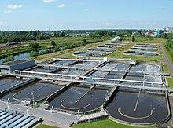

[Wastewater treatment plants](https://en.wikipedia.org/wiki/Wastewater_treatment) rely largely on microorganisms to oxidise organic matter.

Sewage treatment works depend for their ability to clean up water contaminated with organic material on microorganisms that can respire dissolved substances. Respiration may be aerobic, with a well-oxygenated filter bed such as a [slow sand filter](https://en.wikipedia.org/wiki/Slow_sand_filter). [Anaerobic digestion](https://en.wikipedia.org/wiki/Anaerobic_digestion) by [methanogens](https://en.wikipedia.org/wiki/Methanogen) generate useful [methane](https://en.wikipedia.org/wiki/Methane) gas as a by-product.

### **Energy**

Microorganisms are used in [fermentation to produce ethanol](https://en.wikipedia.org/wiki/Ethanol_fermentation), and in [biogas](https://en.wikipedia.org/wiki/Biogas) reactors to produce [methane](https://en.wikipedia.org/wiki/Methane). Scientists are researching the use of [algae to produce liquid fuels](https://en.wikipedia.org/wiki/Algae_fuel), and bacteria to convert various forms of agricultural and urban waste into [usable fuels](https://en.wikipedia.org/wiki/Cellulosic_ethanol).

### **Chemicals, enzymes**

Microorganisms are used to produce many commercial and industrial chemicals, [enzymes](https://en.wikipedia.org/wiki/Enzymes) and other bioactive molecules. Organic acids produced on a large industrial scale by microbial fermentation include [acetic acid](https://en.wikipedia.org/wiki/Acetic_acid) produced by [acetic acid bacteria](https://en.wikipedia.org/wiki/Acetic_acid_bacteria) such as [*Acetobacter aceti*](https://en.wikipedia.org/wiki/Acetobacter_aceti), [butyric acid](https://en.wikipedia.org/wiki/Butyric_acid) made by the bacterium [*Clostridium butyricum*](https://en.wikipedia.org/wiki/Clostridium_butyricum), [lactic acid](https://en.wikipedia.org/wiki/Lactic_acid) made by [*Lactobacillus*](https://en.wikipedia.org/wiki/Lactobacillus) and other [lactic acid bacteria](https://en.wikipedia.org/wiki/Lactic_acid_bacteria), and [citric acid](https://en.wikipedia.org/wiki/Citric_acid) produced by the mould fungus [*Aspergillus niger*](https://en.wikipedia.org/wiki/Aspergillus_niger).

Microorganisms are used to prepare bioactive molecules such as [Streptokinase](https://en.wikipedia.org/wiki/Streptokinase) from the bacterium [*Streptococcus*](https://en.wikipedia.org/wiki/Streptococcus), [Cyclosporin A](https://en.wikipedia.org/wiki/Cyclosporin_A) from the ascomycete fungus [*Tolypocladium inflatum*](https://en.wikipedia.org/wiki/Tolypocladium_inflatum), and [statins produced](https://en.wikipedia.org/wiki/Statins) by the yeast [*Monascus purpureus*](https://en.wikipedia.org/wiki/Monascus_purpureus).

### 

### 

### 

### 

### **Science**

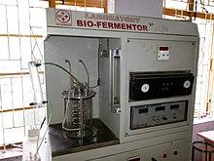

A laboratory [fermentation](https://en.wikipedia.org/wiki/Fermentation) vessel

Microorganisms are essential tools in [biotechnology](https://en.wikipedia.org/wiki/Biotechnology), [biochemistry](https://en.wikipedia.org/wiki/Biochemistry), [genetics](https://en.wikipedia.org/wiki/Genetics), and [molecular biology](https://en.wikipedia.org/wiki/Molecular_biology). The [yeasts](https://en.wikipedia.org/wiki/Yeast) [*Saccharomyces cerevisiae*](https://en.wikipedia.org/wiki/Saccharomyces_cerevisiae), and [*Schizosaccharomyces pombe*](https://en.wikipedia.org/wiki/Schizosaccharomyces_pombe) are important [model organisms](https://en.wikipedia.org/wiki/Model_organism) in science, since they are simple eukaryotes that can be grown rapidly in large numbers and are easily manipulated. They are particularly valuable in [genetics](https://en.wikipedia.org/wiki/Genetics), [genomics](https://en.wikipedia.org/wiki/Genomics) and [proteomics](https://en.wikipedia.org/wiki/Proteomics). Microorganisms can be harnessed for uses such as creating steroids and treating skin diseases. Scientists are also considering using microorganisms for living [fuel cells](https://en.wikipedia.org/wiki/Fuel_cells), and as a solution for pollution.

### **Warfare**

In the [Middle Ages](https://en.wikipedia.org/wiki/Middle_Ages), as an early example of [biological warfare](https://en.wikipedia.org/wiki/Biological_warfare), diseased corpses were thrown into castles during [sieges](https://en.wikipedia.org/wiki/Siege) using catapults or other [siege engines](https://en.wikipedia.org/wiki/Siege_engine). Individuals near the corpses were exposed to the pathogen and were likely to spread that pathogen to others.

In modern times, [bioterrorism](https://en.wikipedia.org/wiki/Bioterrorism) has included the [1984 Rajneeshee bioterror attack](https://en.wikipedia.org/wiki/1984_Rajneeshee_bioterror_attack) and the 1993 release of [anthrax](https://en.wikipedia.org/wiki/Anthrax) by [Aum Shinrikyo](https://en.wikipedia.org/wiki/Aum_Shinrikyo) in Tokyo.

### **Soil**

Microbes can make [nutrients](https://en.wikipedia.org/wiki/Nutrient) and minerals in the soil available to plants, produce [hormones](https://en.wikipedia.org/wiki/Hormones) that spur growth, stimulate the plant [immune system](https://en.wikipedia.org/wiki/Immune_system) and trigger or dampen stress responses. In general a more diverse set of [soil](https://en.wikipedia.org/wiki/Soil_biology) microbes results in fewer plant diseases and higher yield.

**HIDDEN HELPERS IN OUR BODY**

* The human body contains 10 times more bacteria than cells.
* Bacteria help the body with functions like digestion, immunity and keeping potentially harmful bacteria like E. coli from making us sick.
* Bacteria helps synthesize vitamins like biotin, vitamin K and folic acid.

Researchers at Loyola University demonstrated in [a 2010 study](http://www.sciencedaily.com/releases/2010/06/100614171907.htm) how Bacillus, a rod-shaped bacteria found in the digestive tract, bind to immune system cells and stimulate them to divide and reproduce. The research suggests that, years down the road, those with weakened immune systems could be treated by introducing these bacterial spores into the system. These microbes could potentially even help the body fight cancerous tumors.

Bifidobacterium Longum This microorganism is found in large amounts in the intestines of infant. They release several acids which make an environment that is toxic to many virulent bacteria. In this way, they serve to protect humans.

Bacteroides Thetaiotaomicron Humans cannot on their own digest many plant food molecules. Present in the GI tract, the bacteria Bacteroides thetaiotaomicron break down such molecules. This allows humans to digest the components. Without these microbes vegetarians would be in trouble.

Escherichia Coli Escherichia coli bacteria synthesize the vital vitamin K in humans' guts. Abundance of this vitamin allows humans' blood clotting mechanisms to function properly.

Viridans Streptococci These microbes thrive in the throat. Though humans are not born with them, as infants cultures find a way of getting in. They grow there so well that they leave little space for other, more harmful bacteria to colonize.

## **Lactobacillus Reuteri**

Sometimes called the universal probiotic, L. reuteri is found in the colons of most animals, where it can fight pathogenic bacteria. L. reuteri is found in human breast milk and may be responsible for some of the immuno supportive and anti-gas effects associated with breastfeeding.

## **Lactococcus Lactis**

L. lactis has only limited medicinal value compared to other probiotic species, but it offers extensive commercial and culinary value. Almost all forms of cheese and buttermilk are manufactured using appropriate strains of L. lactis.

**FORMATION OF CURD**

[Lactobacillus](https://en.wikipedia.org/wiki/Lactobacillus) is a [genus](https://en.wikipedia.org/wiki/Genus) of [bacteria](https://en.wikipedia.org/wiki/Bacteria) which can convert sugars into [lactic acid](https://en.wikipedia.org/wiki/Lactic_acid) by means of [fermentation](https://en.wikipedia.org/wiki/Fermentation). Milk contains a sugar called [lactose](https://en.wikipedia.org/wiki/Lactose), a disaccharide (compound sugar) made by the glycosidic bonding between [glucose](https://en.wikipedia.org/wiki/Glucose) and galactose (monosaccharides). When [pasteurized milk](https://en.wikipedia.org/wiki/Pasteurized_milk) is heated to a temperature of 30-40 °C, or even at room temperature or refrigerator temperature, and a small amount of old curd or whey added to it, the lactobacillus in that curd or whey sample starts to grow.

**HOW BREAD IS MADE ?**

Many breads are leavened by yeast. The yeast most commonly used for leavening bread is *Saccharomyces cerevisiae*, the same species used for brewing alcoholic beverages. This yeast ferments some of the carbohydrates in the flour, including any sugar, producing carbon dioxide.

**Microorganisms – Cleaning the environment**

Microorganism helps to keep our environment clean because they help to compose the matter with natural process that is done by bacteria and in this way it helps in making manure for soil. This process is known as biodegradation.

**Microorganism as a tool of Bioremediation technology for cleaning the environment –**

**Bioremediation** –

the integration of natural sciences and engineering in order to achieve the application of organisms, cells parts thereof and molecular analogues for products and services.

## **Chemistry**

Most bioremediation processes involve oxidation-reduction (Redox) reactions where a chemical species donates an electron (electron donor) to a different species that accepts the electron (electron acceptor). During this process, the electron donor is said to be oxidized while the electron acceptor is reduced. Common electron acceptors in bioremediation processes include oxygen, nitrate, manganese (III and IV), iron (III), sulfate, carbon dioxide and some pollutants (chlorinated solvents, explosives, oxidized metals, and radionuclides). Electron donors include sugars, fats, alcohols, natural organic material, fuel hydrocarbons and a variety of reduced organic pollutants. The redox potential for common biotransformation reactions is shown in the table.

* Bioremediation refers to the process of using microorganisms to remove the environmental pollutants or prevent pollution.
* The removal of organic wastes by microbes for environmental clean-up is the essence of bioremediation.
* From an ecological point of view, bioremediation depends on the various interactions between three factors: substrate (pollutant), organisms, and environment, as shown in the figure -

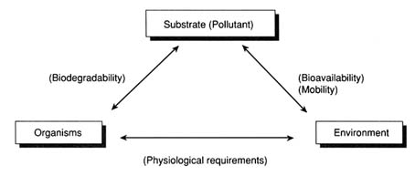

## **Limitations**

Only biodegradable contaminants can be transformed using bioremediation processes.[5] Some compounds, such as highly chlorinated compounds, heavy metals, and radionuclides are not readily biodegradable. Also, microbes sometimes do not fully biodegrade a pollutant and may end up producing a more toxic compound. For example, under anaerobic conditions, the reductive dehalogenation of TCE may produce vinyl chloride which is a known carcinogen.

**THE CLEANING PROCESS OF POLLUTED WATER –**

* In simple terms, bioremediation is a system of sewage treatment where microbes are used to degrade flowing sewage into carbon dioxide and water. The process also reduces the stench from raw sewage.
* However, bioremediation can be effective only in places where environmental conditions permit microbial growth and activity. Where the conditions are not favourable for their growth, manipulation of environmental parameters is carried out to allow microbial growth and allow degradation at a faster rate.
* The microbes simply eat up contaminants such as oil and organic matter (e.g., waste food), convert them and then let off carbon dioxide and water. The process uses naturally occurring bacteria, fungi or plants to degrade substances that are hazardous to human health or the environment.
* For a country such as India, where there is a huge lack of adequate sewage collection and treatment systems, this process could be highly beneficial. Many Indian cities have either very poor or non-existent sewage treatment facilities; conditions in rural areas are no better.
* The technology has been successfully demonstrated in pilot projects by the Central Pollution Control Board. And the National Mission for Clean Ganga is now in the process of using bioremediation for cleaning up some parts of the river.

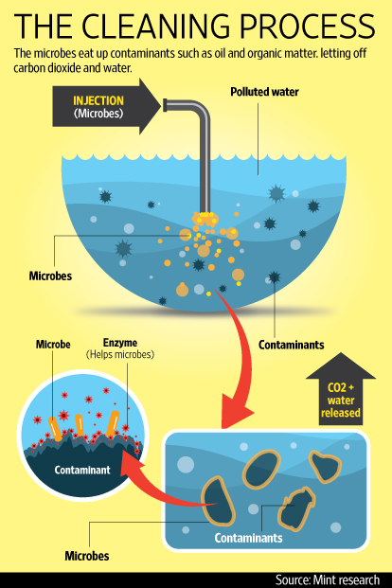

**River ganga -**

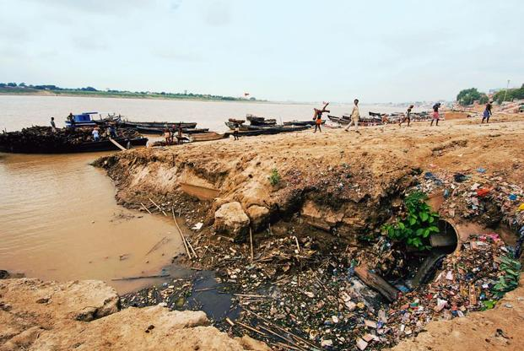

**Solution for polluted air**

* Air is polluted by a variety of volatile organic compounds created by a range of industrial processes.
* While chemical scrubbing has been used to clean gases emitted from chimneys, the newer technique of ‘biofiltration’ is helping to clean industrial gases.
* This method involves passing polluted air over a replaceable culture medium containing microorganisms that degrade contaminants into products such as carbon dioxide, water or salts.
* Biofiltration is the only biological technique currently available to remediate airborne pollutants.



Microbes, after all, are essentially little chemical factories that require less external energy than industrial boilers to perform reactions. They also don't need health and benefits packages, can endure difficult enviroments and be sacrificed by the thousands on a daily basis. Someday, they could be recognized as the employees of the century.

The process works as follows. Air containing substances such as formaldehyde, benzene and/or methanol is captured, mixed with water vapor and channeled into what the company calls a bio-trickling chamber. This first chamber is filled with plastic strips coated in water infused with bacteria.

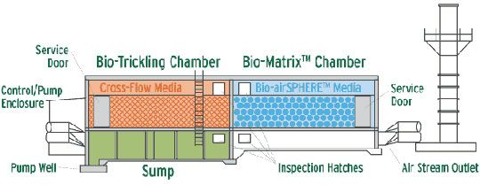

**BACTERIA AND THE ENVIRONMENT**

* This natural process, called biodegradation, happens when microbes like bacteria and fungi break down complex pollutants into simpler substances to gain energy and nutrients.
* Bacteria can even "eat up" pollutants like radioactive materials, pesticides, metals, and industrial solvents.
* It seems like beneficial microflora are one of Mother Nature's most important ways of keeping herself clean.

**BACTERIA AND YOUR ECOSYSTEM**

* Inside your body is a thriving inner ecosystem of micro flora (good bacteria and yeast) that keep you healthy and strong. These healthy bacteria and yeast (a type of fungi) help you digest food, absorb nutrients, regulate your blood sugar and manufacture vitamins and minerals.
* If you eat too much sugar and processed foods, take drugs, live a high stress lifestyle or don't get enough sleep, you create an environment inside your body that encourages the growth of pathogenic (bad) bacteria and fungi like Candida albicans.
* As a result, your inner ecosystem could be out of balance, and you might need a clean up.

**HOW TO INCREASE FERTILITY OF SOIL**

THERE ARE BROADLY TWO CATEGORIES OF SAME METHODOLOGY TO INCREASE THE FERTILITY OF SOIL I.E. USING CHEMICAL FERTILIZER AND BIO FERTILIZER.

**1.BIOFERTILIZER**

A Bio fertilizer (also bio-fertilizer) is a substance which contains living microorganisms which, when applied to seeds, plant surfaces, or soil, colonize the rhizosphere or the interior of the plant and promotes growth by increasing the supply or availability of primary nutrients to the host plant.[1] Bio-fertilizers and nutrients through the natural processes of nitrogen fixation, solubilizing phosphorus, and stimulating plant growth through the synthesis of growth-promoting substances. Bio-fertilizers can be expected to reduce the use of chemical fertilizers and pesticides. The microorganisms in bio-fertilizers restore the soil's natural nutrient cycle and build soil organic matter. Through the use of bio-fertilizers, healthy plants can be grown, while enhancing the sustainability and the health of the soil. Since they play several roles, a preferred scientific term for such beneficial bacteria is "plant-growth promoting rhizobacteria" (PGPR). Therefore, they are extremely advantageous in enriching soil fertility and fulfilling plant nutrient requirements by supplying the organic nutrients through microorganism and their byproducts. Hence, bio-fertilizers do not contain any chemicals which are harmful to the living soil.

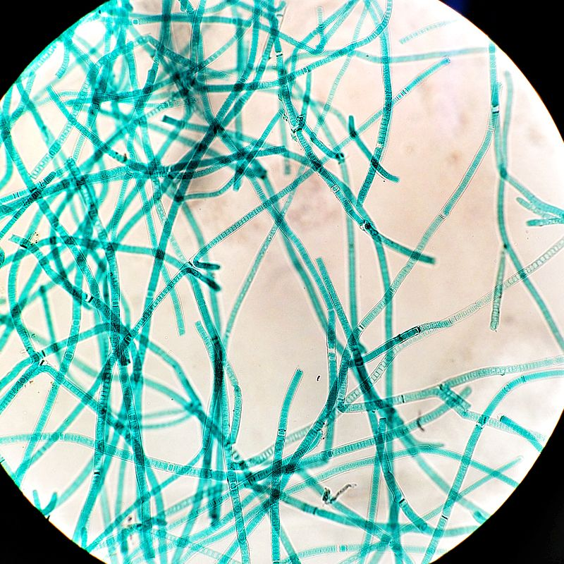

*Tolypothrix, cyanobacteria often used as fertilizer*

2.CHEMICAL FERTILIZER

Chemical fertilizer are effective in improving the the soil fertility by increasing the concentration of chemical content artificially but because of these ways the soil loses its retention capability and many health problems like cancer can be attributed to the overuse of fertilizer in last few decades.These chemicals become part of our food chain and due to biological magnification it affects all the life whether it be human,birds or livestock.

**MEDICAL BIOTECHNOLOGY**

* The industrial application of living organisms is called biotechnology .
* Biotechnology is the use of plants, animals and microorganisms, such as bacteria and fungi, to produce medicines, vaccines and to develop disease testing techniques.
* The biotechnological technique called DNA profiling plays a very important role in forensic science and identification.
* Sometimes it is also referred to as genetic fingerprinting.

DBT’s Medical Biotechnology is an umbrella programme which encompasses a whole range of areas targeted towards bringing about solutions to various medical problems that increase human morbidity and mortality. The programmes aim to prevent human diseases, diagnose them early and also find solutions (therapeutic) that can manage the medical problem.

They include…

|  |  |
| --- | --- |
| Infectious Diseases | Infectious diseases biology programme |
| Infectious Diseases | Human development and disease biology |
| cronic desease (1) | Chronic disease biology |
| Vaccines and Diagnostics | Vaccines and diagnostics |
| Human Genetics And Genome Analysis | Human genetics and genome analysis |
| Stem Cell Research And Regenerative Medicine | Stem cell research and regenerative medicine |
| Biodesign | Biodesign |
| Bioengineering | Bioengineering |

**ANTIBIOTICS**

* Antibiotics are natural substances that can be used to fight bacterial infections.The first antibiotic-producing organism is ‘Penicillium’.
* Penicillin kills bacteria by preventing the formation of their cellular walls. Pre-existing cells are unaffected, but all newly-produced cells grow abnormally.
* Clinically useful antibiotics must be effective against pathogens but have minimal toxicity to humans and human beneficial microflora.

Antibiotics do not fight infections caused by viruses, such as

Colds

Flu

Most coughs and bronchitis

Sore throats, unless caused by strep

If a virus is making you sick, taking antibiotics may do more harm than good. Using antibiotics when you don't need them, or not using them properly, can add to antibiotic resistance. This happens when bacteria change and become able to resist the effects of an antibiotic.

When you take antibiotics, follow the directions carefully. It is important to finish your medicine even if you feel better. If you stop treatment too soon, some bacteria may survive and re-infect you. Do not save antibiotics for later or use someone else's prescription.

**VACCINE**

* The name 'vaccine' comes from the Latin 'vacca' which means 'cow' because the very first vaccine was created for smallpox using cows infected with this disease.
* Vaccines work by triggering the body's immune response without making it sick. A vaccine is introduced to the body either by injection or within a small drink.
* Live vaccines are made from live but 'disabled' pathogens. This type of vaccine produces long-term immunity.

# Types of Vaccines -

Scientists take many approaches to designing vaccines against a microbe. These choices are typically based on fundamental information about the microbe, such as how it infects cells and how the immune system responds to it, as well as practical considerations, such as regions of the world where the vaccine would be used. The following are some of the options that researchers might pursue:

* Live, attenuated vaccines
* Inactivated vaccines
* Subunit vaccines
* Toxoid vaccines
* Conjugate vaccines
* DNA vaccines
* Recombinant vector vaccines

**Commercial production of Alcohol And Wine**



**•*How is alcohol made?***

Alcohol is commercially produced using

a process Called Fermentation.

***•What is fermentation?***

Fermentation is a metabolic process that consumes sugar in the

absence of oxygen. The products are organic acids, gases, or

alcohol.

It mostly occurs in yeast and bacteria, and also in oxygen- starved

muscle cells.

The science of fermentation is known as zymology.

**In simple words :** Fermentation is the process in which yeast breaks down sugar into alcohol and carbon dioxide.

***Yeast + Glucose à Alcohol (Ethanol) + CO2***

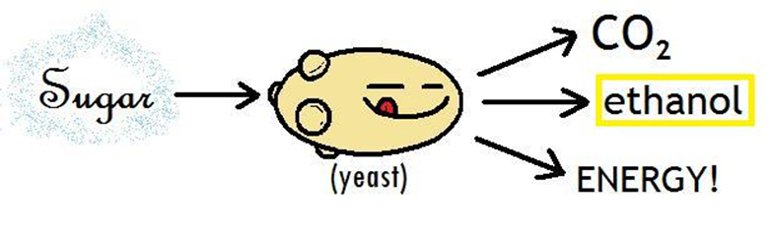

Carbon dioxide gas bubbles out of the fermenting solution into the air leaving a mixture of Ethanol and water.

**Winemaking**



•Wine is an alcoholic beverage prepared by fermenting grapes or any other fruit.

•Winemaking is the art of producing wine, starting with selection of the grapes up to the bottling of finished wine.

•The science of wine and winemaking is known as oenology.

**There are many variants in wine :**

**1. Red Wine**

Red wine is made from dark- coloured grape varieties . the red colour

comes from anthocyanin pigments (also called anthocyanins ) present

in the skin of the grape.

**2. White Wine**

Fermentation of the non-coloured grape pulp produces white wine.

**3. Rosé wine**

It may be the oldest known type of wine. There are three primary ways

to produce rosé wine: skin contact (allowing dark grape skins to stain

the wort),saignee (removing juice from the must early in and

continuing fermentation of the juice separately), and blending

(uncommon and discouraged in most wine growing regions).

**4. Fruit Wine**

Wines from other fruits, such as apples and berries, are usually named

After the fruit from which they are produced combined with the word

"wine" (for example, apple wine and elderberry wine) and are

generically called fruit.

**5. Mead( honey wine)**

Mead, also called honey wine, is created by fermenting honey with

water. As long as the primary substance fermented is honey , the drink

Is considered mead.

**6. Starch-based "wine“**

Other beverages called "wine", such as barley wine and rice wine,

(e.g. sake) are made from starch-based materials.

**Winemaking comprises the following processes :**

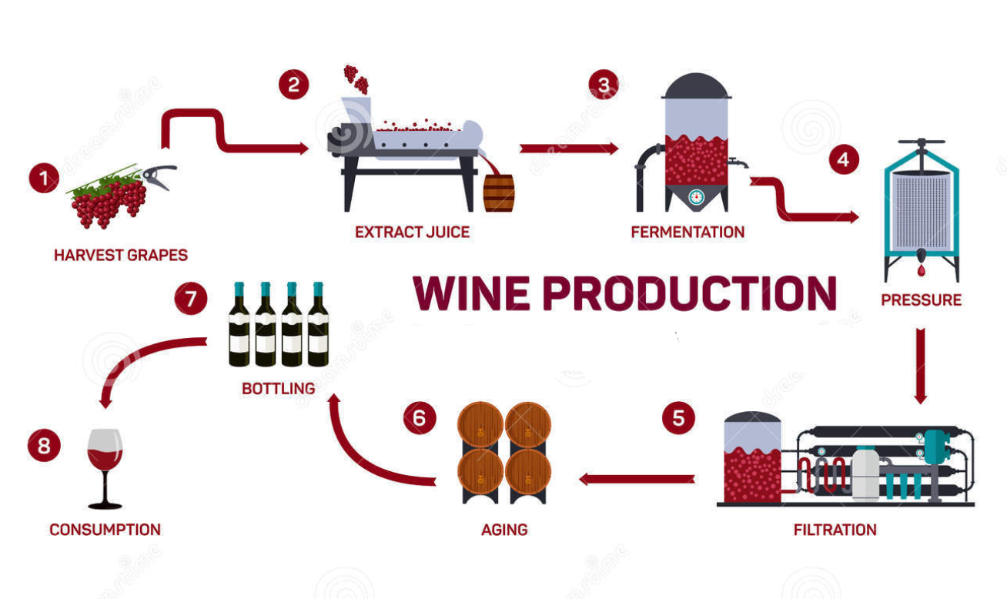

**1. Harvesting and destemming**

Harvest is the picking of the grapes and in many ways the first step in

delicious wine production. Grapes are either harvested mechanically or

by hand.

**2. Crushing or Pressing**

Crushing is the process when gently squeezing the berries and breaking

the skins to start to liberate the contents of the berries. In traditional

and smaller-scale winemaking , the harvested grapes are sometimes

crushed by trampling them barefoot or by the use of inexpensive small

scale crushers.

**3. Fermentation**

Yeast is normally already present on the grapes. During primary the

fermentation, the yeast cells feed on the sugars in the must and

multiply, producing carbon dioxide gas and alcohol.

During the secondary fermentation and aging process, which takes

three to six months, the fermentation continues very slowly. The wine is

kept under an airlock to protect the wine from oxidation.

Proteins from the grape are broken down and the remaining yeast cells

and other fine particles from the grapes are allowed to settle.

**4. Blending and fining**

Once fermentation is complete, clarification begins. Clarification is the

process in which solids such as dead yeast cells, tannins, and proteins

are removed. Fining agents are used during winemaking to remove

tannins Gelatin has been used in winemaking for centuries and is

recognized as a traditional method for wine fining, or clarifying. It is

also the most commonly used agent to reduce the tannin content.

Generally no gelatin remains in the wine because it reacts with the wine

components, as it clarifies.

**5. Aging and Bottling**

The ***aging of wine*** is potentially able to improve the quality of wine. The

wine bottles then are traditionally sealed with a cork. It will preserve

the wine and prevent unwanted fermentation in the bottle. Now we are

using screw caps for this purpose.

THANK YOU